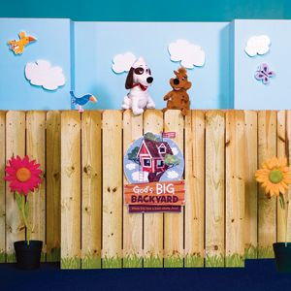
Come learn about Serving God – Right in God’s BIG BACKYARD !!!
This year’s Vacation Bible School will be held at Westminster Presbyterian Church August 3 - 6, Monday – Thursday, from 5:30 – 8 pm. A light supper will be served at 5:30 with classes, music, crafts, etc. beginning at 6 pm. There is no charge to attend Bible School and we have classes for children age 3 – grade 5. This year’s theme is “Serving one another in God’s Big Backyard” and everyone is invited to come and meet Cookie, the dog , and all his friends in God’s Big Backyard
August 3 – 6
6 – 8 pm

Come learn about Baby Moses, Zaccheus & many more. You’ll learn how we can serve our Friends, our Families, our Neighbors, our World and God through our actions and deeds.
Plans for the week look wonderful and I’m sure you’ll all have a great time. Be prepared for lively music, great crafts and much, much more.

Below is a registration form. If you want to sign your children, grandchildren, friends or neighbors up for the week, please fill out the form and get it to any of the church offices or send it directly to Westminster Pres. – 2915 Glenn Ave. – Sioux City, IA 51106.
VBS is a co-operative effort between Westminster, Third & Morningside Pres. Churches
____________________________________
Parent Name: _____________________________________________________
Address: _________________________________________________________
Phone: Home ________________ Cell __________________
Child(ren)’s Info:
Name _________________________ Age _____ Grade completed ______
Name _________________________ Age _____ Grade completed ______
Name _________________________ Age _____ Grade completed ______
Do any of these children have allergies ( food, etc.) that we need to know about:

# who will be eating dinner at VBS ______
Who will be picking child(ren) up from VBS _________________________

